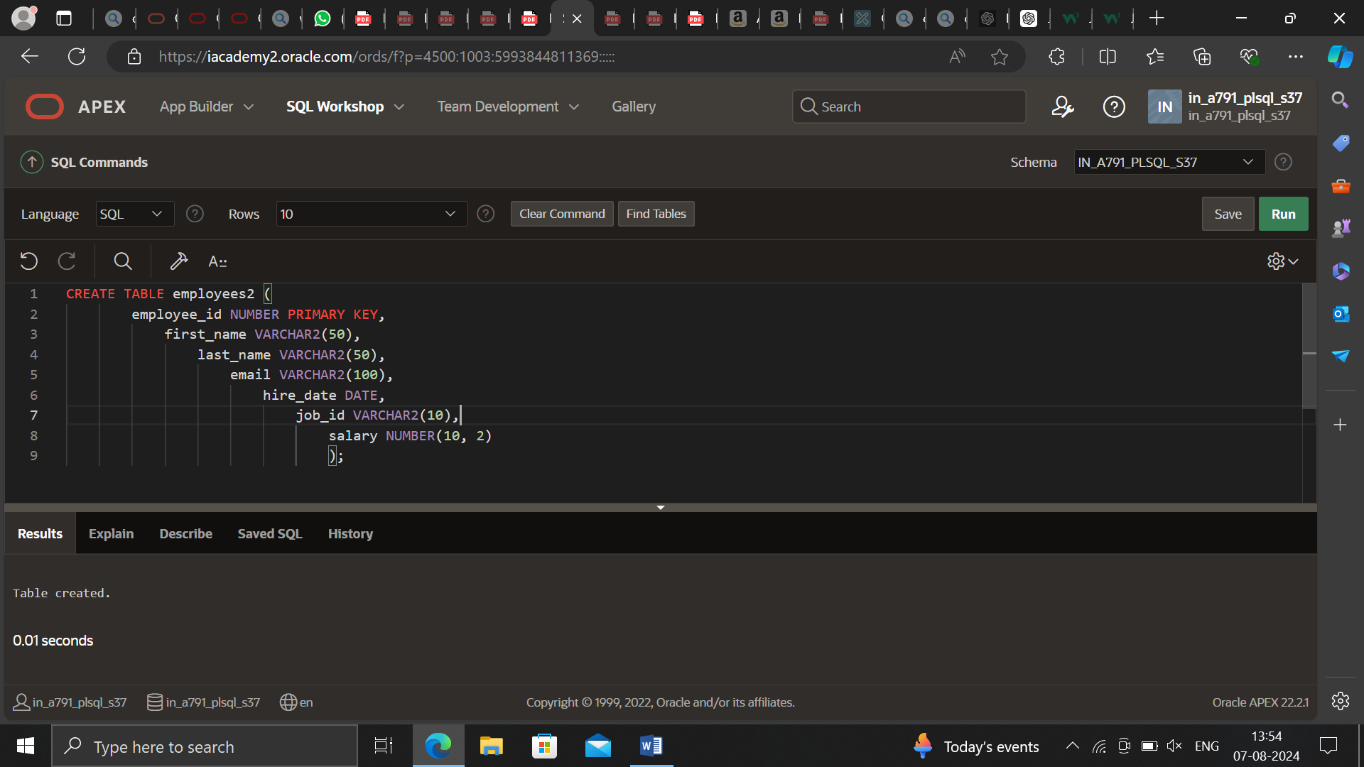

CREATE TABLE employees (

employee_id NUMBER PRIMARY KEY,

first_name VARCHAR2(50),

last_name VARCHAR2(50),

email VARCHAR2(100),

hire_date DATE,

job_id VARCHAR2(10),

salary NUMBER(10, 2)

);

INSERT INTO employees (employee_id, first_name, last_name, email, hire_date, job_id, salary)

VALUES (1, 'John', 'Doe', 'john.doe@example.com', TO_DATE('2022-01-01', 'YYYY-MM-DD'), 'DEV', 50000);

INSERT INTO employees (employee_id, first_name, last_name, email, hire_date, job_id, salary)

VALUES (2, 'Jane', 'Smith', 'jane.smith@example.com', TO_DATE('2022-02-01', 'YYYY-MM-DD'), 'HR', 60000);

INSERT INTO employees (employee_id, first_name, last_name, email, hire_date, job_id, salary)

VALUES (3, 'Bob', 'Johnson', 'bob.johnson@example.com', TO_DATE('2022-03-01', 'YYYY-MM-DD'), 'SALES', 55000);

INSERT INTO employees (employee_id, first_name, last_name, email, hire_date, job_id, salary)

VALUES (4, 'Alice', 'Brown', 'alice.brown@example.com', TO_DATE('2022-04-01', 'YYYY-MM-DD'), 'FIN', 70000);

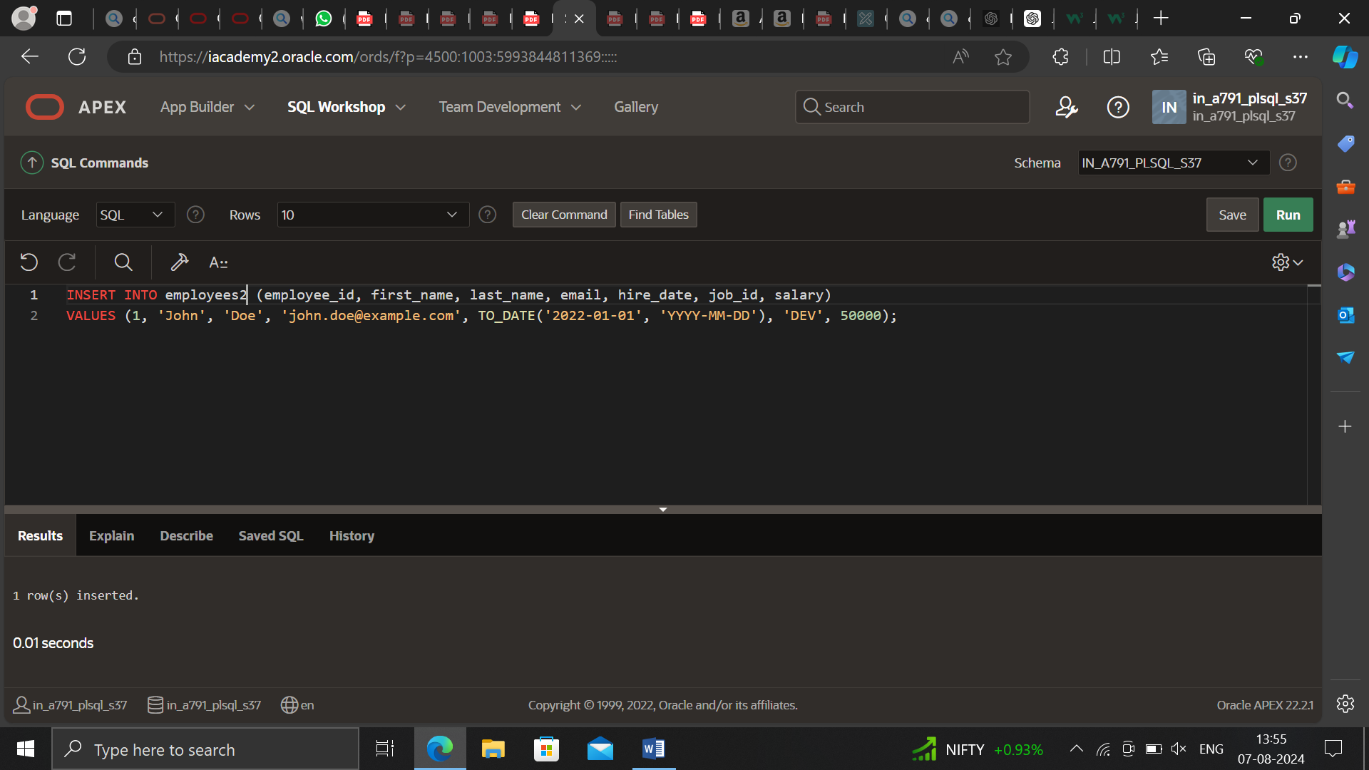

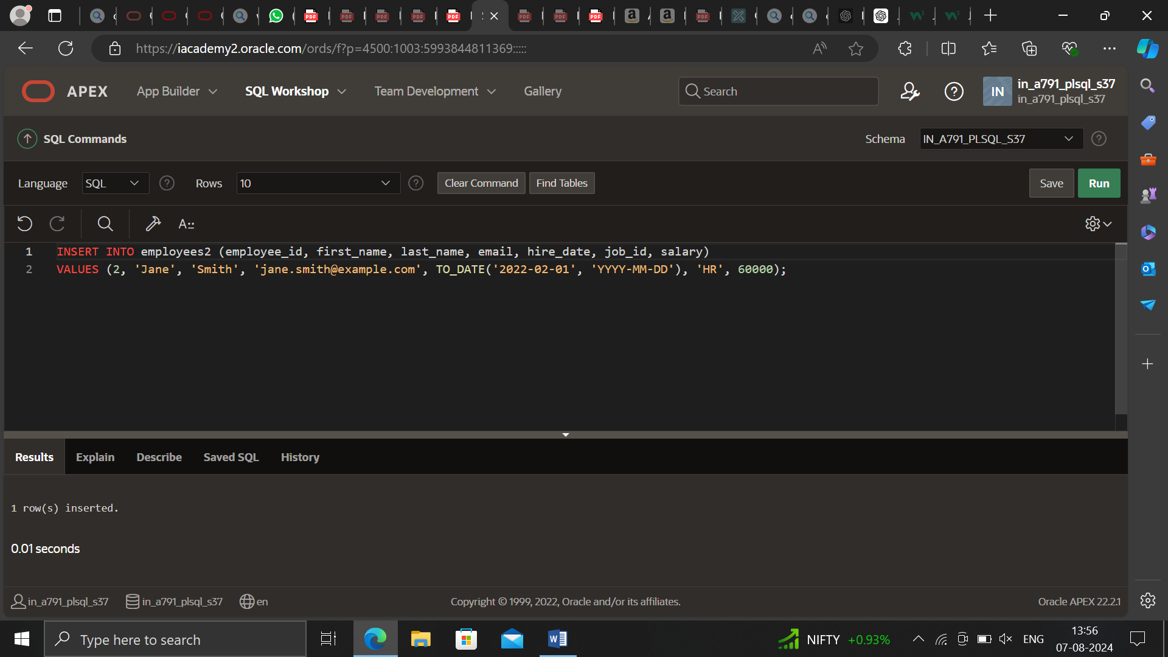

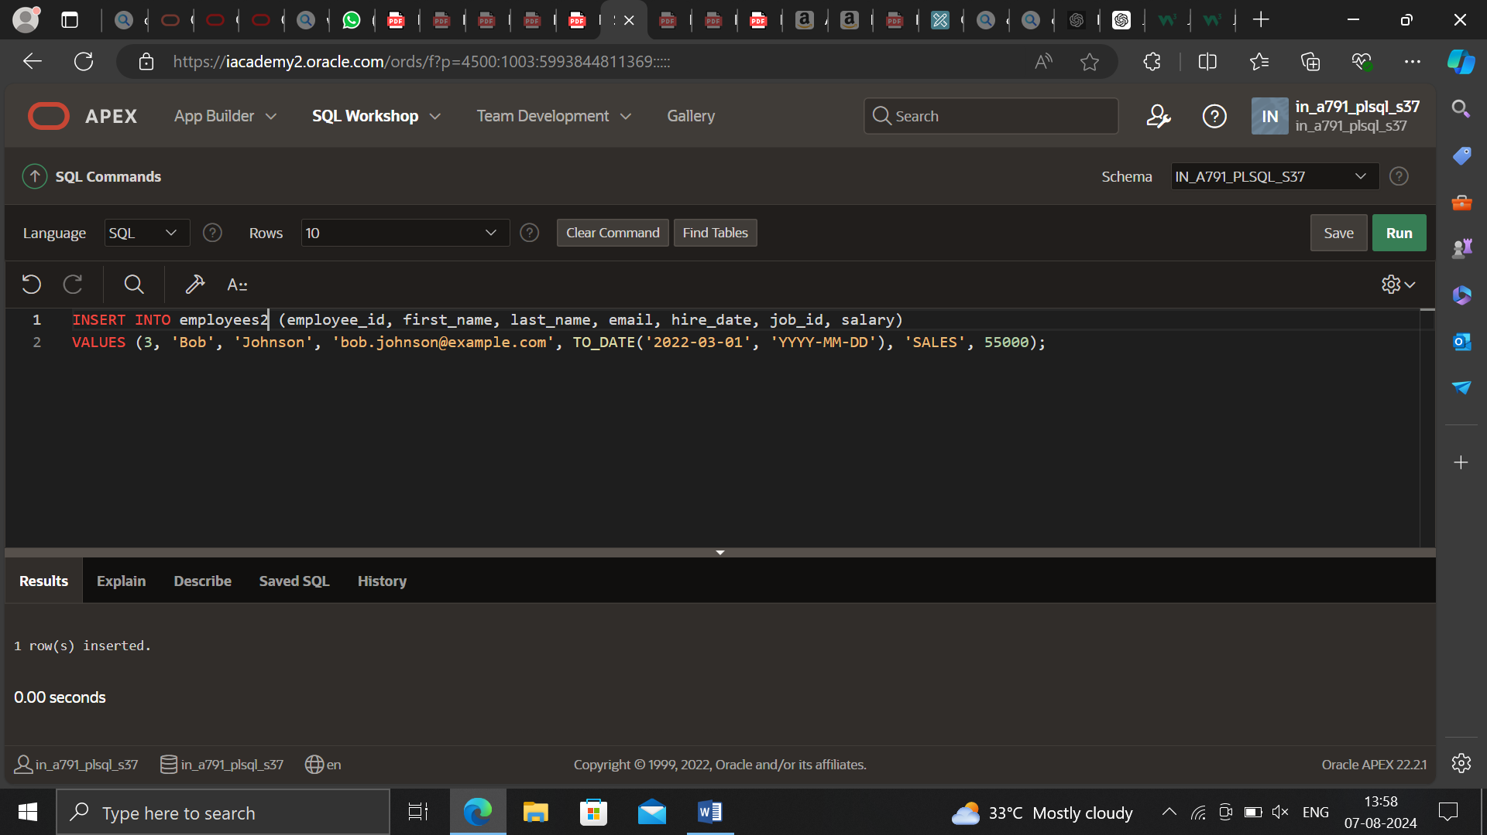

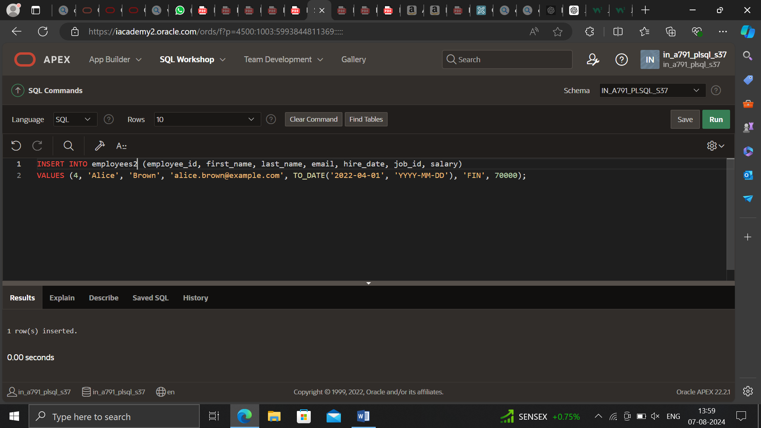

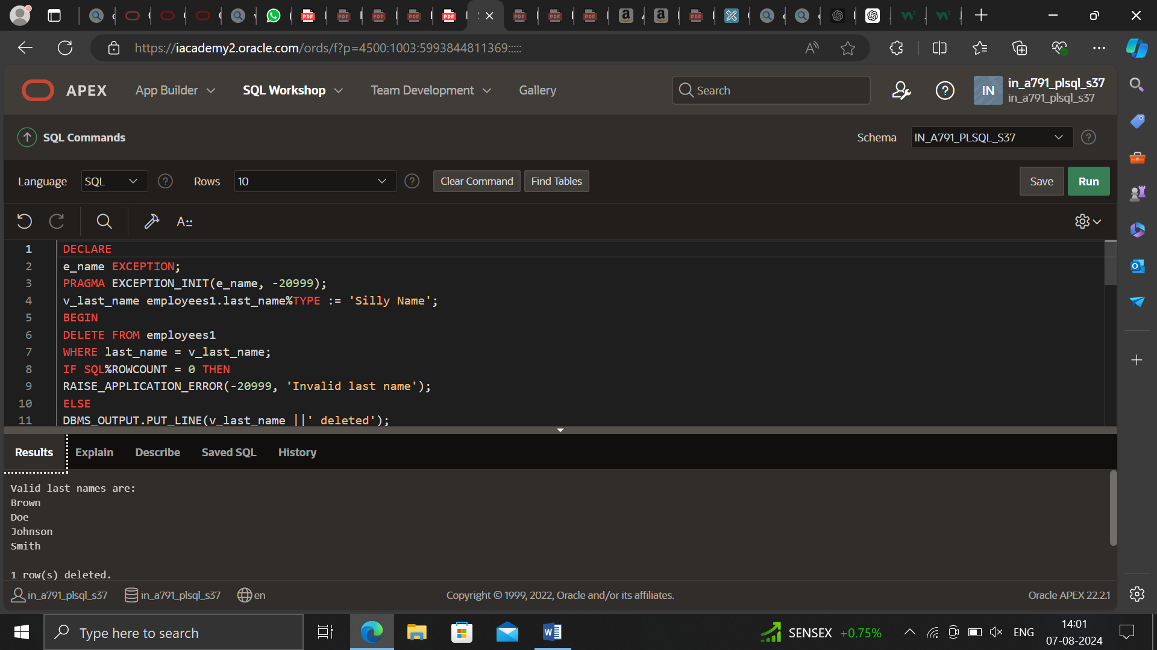

DECLARE

e_name EXCEPTION;

PRAGMA EXCEPTION_INIT(e_name, -20999);

v_last_name employees.last_name%TYPE := 'Silly Name';

BEGIN

DELETE FROM employees

WHERE last_name = v_last_name;

IF SQL%ROWCOUNT = 0 THEN

RAISE_APPLICATION_ERROR(-20999, 'Invalid last name');

ELSE

DBMS_OUTPUT.PUT_LINE(v_last_name ||' deleted');

END IF;

EXCEPTION

WHEN e_name THEN

DBMS_OUTPUT.PUT_LINE('Valid last names are: ');

FOR c1 IN (SELECT DISTINCT last_name FROM employees) LOOP

DBMS_OUTPUT.PUT_LINE(c1.last_name);

END LOOP;

WHEN OTHERS THEN

DBMS_OUTPUT.PUT_LINE('Error deleting from employees');

END;